Figure-1.1. Verilog Source code for 1-bit FullAdder
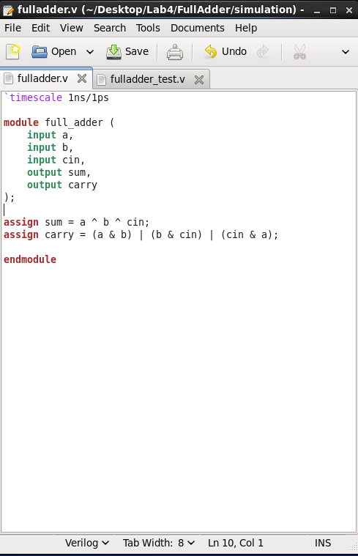

Figure-1.2. Verilog Source code for 1-bit FullAdder Test-bench
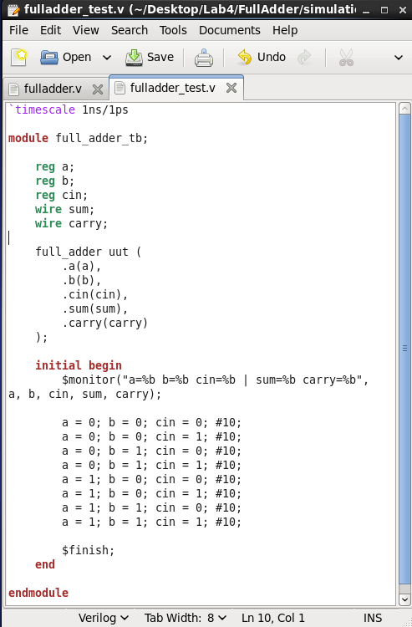

Figure-1.3. NCLaunch window of 1-bit FullAdder showing successful compilation (no errors in the Command Entry Window)
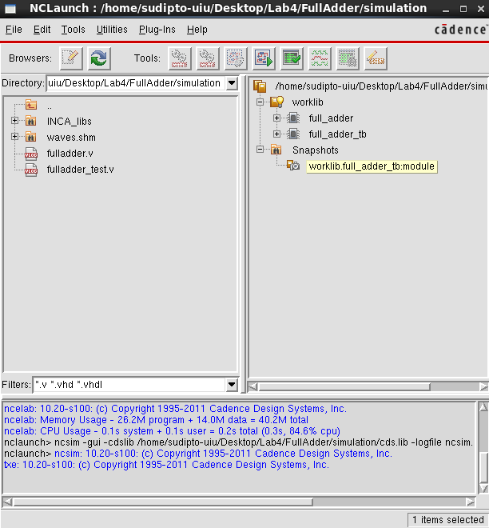

Figure-1.4. SimVision window for 1-bit FullAdder Test-bench, showing the inputs, selector lines, and output
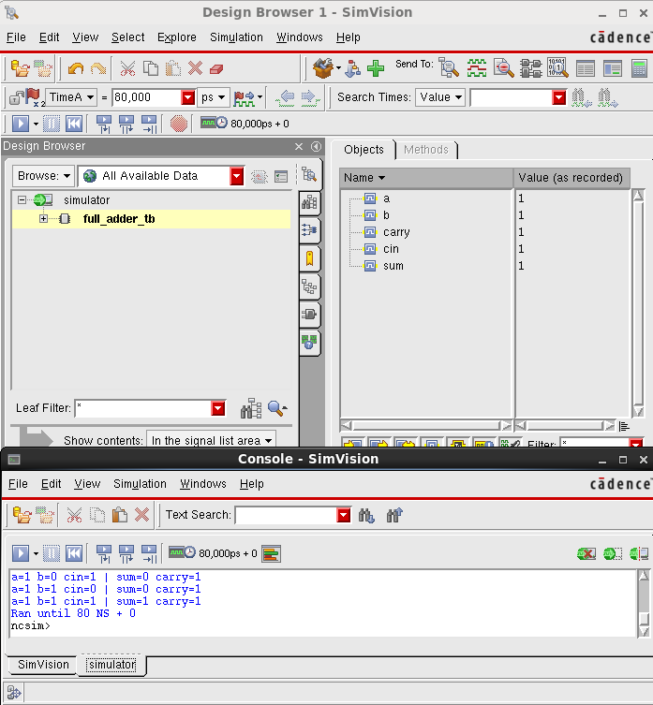

Figure-1.5. SimVision Output Waveform for 1-bit FullAdder Test-bench, showing the inputs, selector lines, and output
